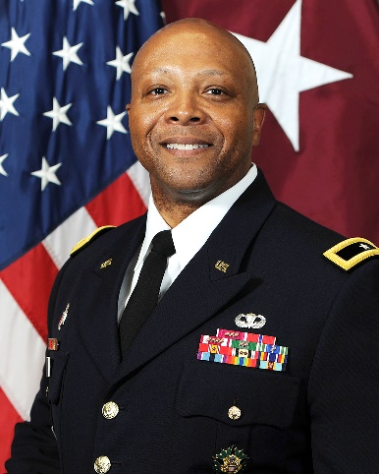
Brigadier General Shan K. Bagby
Commanding General, U.S. Army Regional Health Command – Central
Chief, U.S. Army Dental Corps
Deputy Director, Small Market and Stand-Alone MTF Organization (Defense Health Agency)

Brigadier General Bagby earned his bachelor’s degree in physics from Rutgers University on an ROTC scholarship. Following that, he earned a Doctor of Dental Medicine degree from the University of Pittsburgh, a master’s degree in healthcare administration from Baylor University, and a master’s degree in strategic studies from the U.S. Army War College. He completed Oral and Maxillofacial Surgery (OMS) residency training at Martin Luther King, Jr./Drew Medical Center in Los Angeles, and fellowship training in OMS trauma surgery at the University of Texas Health Science Center in Houston.
His previous career assignments include: Commanding General, Brooke Army Medical Center and Deputy Market Director, San Antonio Military Health System; Deputy Commanding General (Support), U.S. Army Medical Command; Deputy Chief of Staff for Support, G-1/4/6, Office of The Surgeon General; Deputy Chief of Staff/Troop Commander, U.S. Army Medical Command; Commander, U.S. Army Dental Health Activity, Joint Base Lewis-McChord, Washington; Chief, Dental Corps Branch, U.S. Army Human Resources Command, Fort Knox, Kentucky; Chairman and Program Director, Oral and Maxillofacial Surgery Residency Program at Joint Base San Antonio-Fort Sam Houston, Texas; Commander, 561st Medical Company (Dental Services), Grafenwoehr, Germany; Assistant Residency Director, U.S. Army Dental Health Activity, Fort Sam Houston; and Instructor, Oral Surgery at Walter Reed Army Medical Center, Washington, D.C.
He is a graduate of the Army Medical Department Officer Basic and Advanced Courses, Airborne Course, U.S. Army Command and General Staff College, and U.S. Army War College.
His awards and decorations include the Legion of Merit (three Oak Leaf Clusters), Bronze Star Medal, Meritorious Service Medal (four Oak Leaf Clusters), Army Commendation Medal (two Oak Leaf Clusters), Army Achievement Medal (one Oak Leaf Cluster), Meritorious Unit Citation, National Defense Service Medal, Iraq Campaign Medal (two bronze service stars), Global War on Terrorism Service Medal, Overseas Service Ribbon (two awards) and the Army Parachutist Badge. He holds the Army Surgeon General’s “A” Proficiency Designator and is a member of the Order of Military Medical Merit (O2M3). He is a Fellow of the American Association of Oral and Maxillofacial Surgeons and is board certified by the American Board of Oral and Maxillofacial Surgery.

