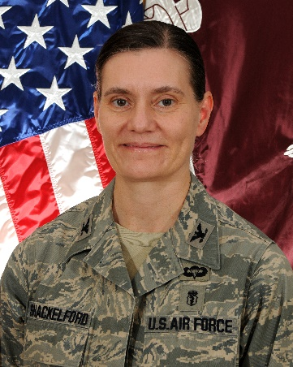
Colonel Stacy Shackelford, USAF, Medical Corps
Col Shackelford is the Chief of Defense Health Agency (DHA) Joint Trauma System (JTS) and the first JTS Chief to serve under the DHA governance. Col Shackelford previously served as the JTS Chief of Education and Performance Improvement.
Col Shackelford was instrumental in standing up the JTS Committees for Surgical and En Route Combat Casualty Care. She is also known for her contributions to prolonged field care (PFC) and her work in predeployment training. She was awarded the Committee on Tactical Combat Casualty Care Frank K. Butler award for 2016 for her many contributions to improving military prehospital trauma care. She also received the Joint Service Commendation medal and the Bronze Star.
She deployed five times to CENTCOM. During her last three deployments, Col Shackelford served as the forward Joint Theater Trauma System director for Operation Enduring Freedom, managing a team of 24 personnel and coordinating trauma care delivery for three Role 3 and 22 Role 2 surgical facilities throughout Afghanistan. She twice served as the dual-hatted Operation Freedom's Sentinel trauma system director/Task Force Medical-Afghanistan deputy commander for clinical services. She also led the first CENTCOM prehospital trauma system assessment in Afghanistan in 2012, the CENTCOM trauma system assessment in Iraq and Afghanistan in 2018, and the AFRICOM trauma system assessment in 2019.
Prior to joining JTS, Col Shackelford led education and training for the Air Force's premiere trauma training platform, Center for Sustainment of Trauma and Readiness Skills, University of Maryland Shock Trauma Center in Baltimore. She served as president of the Excelsior Society 2017-2018 and works integrally with the American College of Surgeons as the Region Chief for the US Military, Canadian Military and Veterans Affairs to the Committee on Trauma.
Col Shackelford was commissioned through the U.S. Air Force Academy in 1989 and attended medical school at Tulane University, general surgery residency at the University of Utah, and trauma fellowship at the University of Southern California/Los Angeles County. Upon entering active duty, she completed Air Command and Staff College and Air War College and served as Deputy Chief of Medical Staff and Surgical Flight Commander.

