10
PRINT | E-MAIL
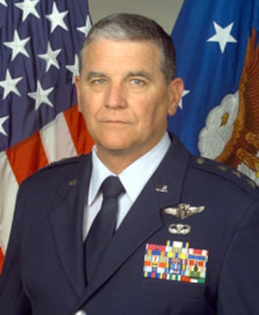
DOWNLOAD HI-RES
Lt. Gen. (Dr.) Paul K. Carlton Jr. is The Surgeon General of the Air Force, Headquarters U.S. Air Force, Bolling Air Force Base, D.C. He serves as functional manager of the U.S. Air Force Medical Service. He advises the Secretary of the Air Force and Air Force Chief of Staff, as well as the Assistant Secretary of Defense for Health Affairs on matters pertaining to the health of Air Force people. He has authority to commit resources worldwide for the Air Force Medical Service, to make decisions affecting the delivery of medical services, and to develop plans, programs and procedures to support peacetime and wartime medical service missions. He exercises direction, guidance and technical management of more than 42,400 people assigned to 78 medical facilities worldwide.
General Carlton was commissioned after being honored a distinguished graduate of the U.S. Air Force Academy in 1969. He is a fellow and former Air Force governor of the American College of Surgeons. He was named a consultant in general surgery to the Air Force surgeon general in 1981. He conceptualized and implemented the first Air Force rapid-response surgical team in Europe -- the flying ambulance surgical trauma team. He remains an active surgeon having performed more than 4,000 operations as principal surgeon and 6,000 as first assistant. He has published extensively in medical literature.
An active flier, General Carlton holds Federal Aviation Administration commercial, instrument, multi-engine, glider and instructor ratings. During Operation Desert Storm, he commanded the 1702nd Air Refueling Wing Contingency Hospital, completing 32 combat support missions and 140 combat flying hours in the C-21, C-130, KC-10 and KC-135.
EDUCATION
1969 Bachelor of science degree, U.S. Air Force Academy, Colorado Springs, Colo.
1973 Doctor of medicine, University of Colorado, Denver
ASSIGNMENTS
1. September 1969 - May 1973, medical student, University of Colorado, Denver
2. July 1973 - June 1978, resident, general surgery, Wilford Hall USAF Medical Center, Lackland Air Force Base, Texas
3. June 1978 - April 1979, staff surgeon, Royal Air Force Lakenheath, England
4. April 1979 - May 1982, Chief, General Surgery, USAF Hospital, Luke Air Force Base, Ariz.
5. May 1982 - August 1985, Chairman, Department of Surgery, USAF Regional Medical Center, Wiesbaden Air Base, West Germany
6. August 1985 - May 1988, Commander, USAF Hospital, Torrejon Air Base, Spain
7. May 1988 - August 1991, Commander, USAF Medical Center, Scott Air Force Base, Ill. (October 1990 - March 1991, Commander, 1702nd Air Refueling Wing Contingency Hospital, Southwest Asia)
8. August 1991 - September 1994, Director, Medical Services and Training, Headquarters Air Education and Training Command, Randolph Air Force Base, Texas
9. September 1994 - May 1999, Commander, 59th Medical Wing, Wilford Hall USAF Medical Center, Lackland Air Force Base, Texas
10. May 1999 - November 1999, Commander and Director, Air Force Medical Operations Agency, Office of the Surgeon General, Bolling Air Force Base, D.C.
11. December 1999 - present, The Surgeon General of the Air Force, Headquarters U.S. Air Force, the Pentagon, Bolling Air Force Base, D.C.
MAJOR AWARDS AND DECORATIONS
Distinguished Service Medal with oak leaf cluster
Legion of Merit with oak leaf cluster
Airmans Medal
Meritorious Service Medal
Air Medal
Air Force Commendation Medal
National Defense Service Medal with service star
EFFECTIVE DATES OF PROMOTION
Second Lieutenant Jun 4, 1969
First Lieutenant Dec 4, 1970
Captain Jun 4, 1972
Major Jun 4, 1975
Lieutenant Colonel Jun 4, 1980
Colonel Oct 1, 1985
Brigadier General Oct 1, 1991
Major General May 25, 1995
Lieutenant General Dec 1, 1999

